# Article XX Vacation Rental Regulations

## (Draft Outline)

**Scope:** The purpose of this Article is to establish the local regulations for the use of privately owned single-family or two-family dwelling units as vacation rentals. The regulations are intended to minimize the potential adverse secondary effects on surrounding neighborhoods, to prevent the increase and over-concentration of transient and commercial uses in residential neighborhoods and zoning districts, impose reasonable limitations to ensure the long-term availability of housing stock in compliance with local regulations, the General Plan, and other policies, and to ensure neighborhood compatibility with vacation rentals under the framework of this Article.

**Definitions:**

1. **Hosted:** A vacation rental where the property owner or primary occupant lives in the home at the same time the vacation rental activity is taking place.
2. **Snow Storage:** An area set aside for the storage of snow. The area may be landscaped, paved, or covered with natural vegetation.
3. **Un-hosted:** A vacation rental where the property owner does not live in the home while the vacation rental activity is taking place.
4. **Vacation Rental:** The rental of a dwelling for the purpose of overnight lodging for a period of not more than 30 days. When there is more than one dwelling on a property as part of a dwelling group, the owner/operation/contact person/ agent may live in a dwelling that is not used as a vacation rental. A vacation rental does not include the renting of individual rooms in a dwelling unit while the primary occupant remains on site.

**Permits Required:** A vacation rental shall not be allowed in the unincorporated part of the county without first securing a Vacation Rental Activity Permit (VR Activity Permit).

1. It is unlawful for any person to conduct, engage in, or allow to be conducted or engaged in, the business of vacation rentals in the unincorporated portion of Siskiyou County, unless the County has issued such person a VR Activity Permit under this Article and the permit is in effect. The fact that an owner possesses other types of state or county licenses or permits shall not exempt the owner from obtaining a VR Activity Permit under this article, nor shall the terms and conditions of any other such permit or license modify the requirements of a permit granted under this article.
2. Only the property owner is eligible to apply for, and be issued, an VR Activity Permit, and the owner shall be directly responsible for the management of the unit though the owner may hire a property management agent.
3. VR Activity Permits shall be limited to one per parcel and one per person regardless of whether the ownership interest is in whole or in part. A VR Activity Permit shall not be approved if a person with an ownership interest in the property, whether in whole or in part, has an existing VR activity permit on another property within Siskiyou County.
4. VR Activity Permits are permissible in the following zoning districts: Res-1, Res-2, Res-3, Res-4, C-R, C-U, C-C, C-H, R-R, AG-1, and AG-2 and prohibited in any other zoning district.
5. All vacation rental property owners must obtain a valid business license.
6. All owners shall be responsible for obtaining a transient occupancy tax certificate and for complying with Chapter 4, “UNIFORM TRANSIENT OCCUPANCY TAX”. An owner may contract with a management company or property manager to collect, disburse, report, and maintain all records related to transient occupancy tax, but the owner remains responsible for any failure to collect, disburse, or accurately report such tax.
7. All owners shall conduct vacation rentals in compliance with all required county permits, licenses, and regulations. The owner shall be responsible for the payment of all required inspection fees, permit fees, and taxes.

**General Standards and Requirements:** The following identifies all general standards and requirements that must be met prior to issuance of the VR Activity Permit:

1. Vacation rentals are only allowed within a single or two-family dwelling unit.
2. The vacation rental shall be managed by a County resident or professional property management firm located in Siskiyou County, and such resident or firm shall be available on a twenty-four (24) hour basis.
3. The maximum rental period for each occupancy shall be thirty (30) consecutive days.
4. Vacation rental properties shall:
   1. Meet the Uniform Housing Code.
   2. Meet the existing State and local water and sewage disposal regulations, including testing of the water supply as required, if provided by a private water source.
5. Accessory uses. Pools, spas, saunas, and shared laundry facilities, if provided, are considered to be public facilities and shall be subject to Health and Building Department review for compliance with State and local regulations for public pools and laundries.
6. Parking. One off-street parking space shall be provided for the vacation rental, plus one additional space for each bedroom. Such spaces may be provided in tandem.
7. Signs. One non-illuminated sign indicating the property is a vacation rental, not in excess of two (2) square feet in area, shall be permitted.
8. The maximum occupancy is limited to the number and size of sleeping rooms. Each sleeping room shall have not less than seventy (70) square feet of floor area for the first two (2) occupants. The floor area requirement shall increase at a rate of fifty (50) square feet for each occupant in excess of two (2). In no instance shall the occupancy exceed ten (10) persons.
9. Trash collection. With the exception of trash properly deposited in trash collection receptacles, accumulation of trash and debris outside of a vacation rental at any time is prohibited. Weekly trash collection must be provided for each vacation rental. Each rental must provide one (1) bear-proof trash receptable.
10. The property owner must show proof that 4290 and 4291 inspections by Cal Fire have been completed prior to issuance of permit.
11. Noise Limitations. The VR shall not create noise impacts to surrounding properties and uses that exceed noise standards set out in the County's General Plan, Noise Element.
12. Amplified Sound. Outdoor amplified sound shall not be allowed at any time associated with a vacation rental.
13. At any time while the property is in use as a vacation rental, the use of firearms or fireworks upon the property by the vacation renter is prohibited.
14. The applicant shall include and reference their VR permit number on any written advertisement for the vacation rental, including online advertisements.
15. The following notices shall be posted on or next to the front door within the subject vacation rental at all times that the property is being used as a vacation rental and shall conform in communicating the required information.
    1. The complete VR Activity Permit that was approved and issued by the Siskiyou County Planning Division for the subject vacation rental; and
    2. A notice that details the following information, including but not limited to:
       1. Parking restrictions.
       2. The prohibition of on-street parking along Big Canyon Drive.
       3. Prohibition of all outdoor burning.
       4. Prohibition of the use of firearms or fireworks upon the property at any time by the vacation renter.
       5. Emergency contact information, including the Siskiyou County Public Health Department, the 24-hour contact information for the property manager and plumber in the event of an emergency.
       6. A list of unacceptable items for disposal in the septic system such as diapers, feminine napkins, paper towels, etc.
       7. Emergency exits and emergency escape diagram.
       8. Refuse collection regulations and collection times.
       9. Restrictions on loud noise (i.e., music, parties) after 10 P.M.
       10. A site diagram showing the water shutoff valve location, location of the shutoff tool(s), if any, and a narrative of how to shut off these valves if necessary.
       11. Any other applicable or required information.
16. All outdoor burning is prohibited. Cooking fires contained within an enclosed grill, smoker, or similar device are exempt from the prohibition.
17. The applicant shall provide properly maintained fire extinguishers.
18. Smoke detectors and carbon monoxide detectors are required to be installed and maintained as per the current building code before the issuance of the VR permit.
19. Proof that the homeowner exemption was utilized for two consecutive years is required prior to issuance of the VR permit.
20. Snow Storage Requirements. Vacation rentals operating within the Region 1 (McCloud) and Region 2 (South County) must provide snow storage space from the months of November to February.

The snow storage area requirements are as follows:

|  |  |
| --- | --- |
| *Flat Roof Snow Load* | *Snow Storage %* |
| 55 pounds per square foot or less | 25% |
| 55-60 pounds per square foot or less | 40% |

Usable snow storage areas shall be identified on the site plan and shall be accessible to snow-removal equipment and clear of obstructions. All designated snow storage areas shall be at least 10 feet wide or deep in the smallest dimension or based upon demonstration of alternative methods (i.e., equipment and size). Heavily landscaped areas shall be protected from snow removal.

**Location and Applicability:** This article applies to any person renting out their single or two-family dwelling unit within the unincorporated area of the county and within the following zoning districts: Res-1, Res-2, Res-3, Res-4, C-R, C-U, C-C, C-H, R-R, AG-1, and AG-2, subject to compliance with the below criteria:

1. All vacation rentals must be un-hosted vacation rentals. The County does not regulate hosted vacation rentals.
2. Vacation rentals are regulated by regional area. The following standards and restrictions apply:

|  |  |  |  |  |  |
| --- | --- | --- | --- | --- | --- |
| **Policy Matrix: Vacation Rental Policy Recommendations** | | | | | |
|  |
| *Region* | *2.5-acre minimum* | CUP or *Activity Permit* | *Inspection* | *Must utilize Homeowner Exemption for 2 consecutive years* | *Cap on Permits\** |  |
| McCloud | No | Activity Permit | Every 3 years | Yes | 5% |  |
| South County: Dunsmuir/Mount Shasta, Weed/Lake Shastina | Yes | Activity Permit | Every 3 years | Yes | 5% |  |
| North County: Grenada, Yreka, Happy Camp/Seiad Valley Klamath River/North Yreka, Scott Valley, Butte Valley, Montague | No | Activity Permit | Every 3 years | Yes | No |  |

*Vacancy rate caps will be reviewed every 5 years

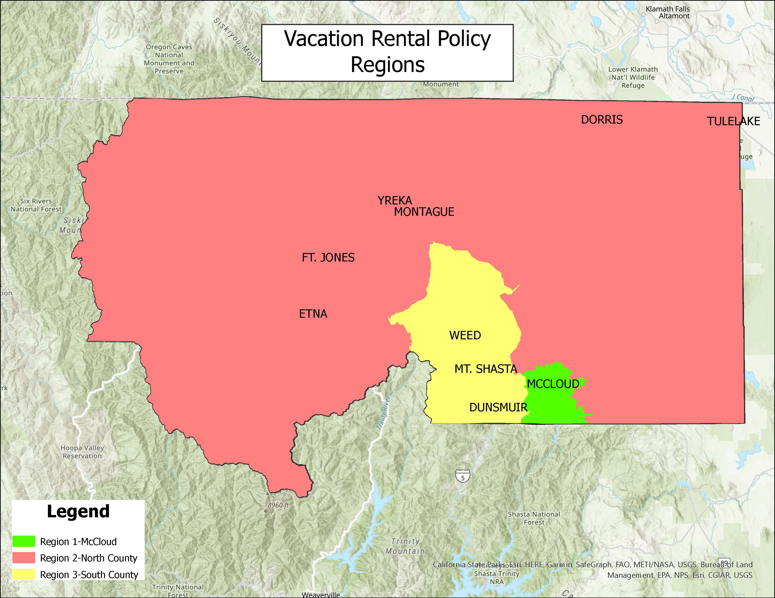

**Vacation Rental Activity Prohibited:** The following structures are not allowed to be utilized as vacation rentals:

1. Accessory Dwelling Units (ADUs).
2. Shipping containers and outdoor areas, which include tipis (teepees), yurts, and treehouses.
3. Sleeping quarters in vans or recreational vehicles (RVs).
4. Properties under Williamson Act contract.
5. Vacation rentals within the Sphere of Influence of the City of Mount Shasta shall only be allowed on parcels of two and one-half (2.5) acres or greater.
6. Any other structure that is unpermitted.
7. Any other structure that is unpermitted for human habitation.
8. Properties that are located within the Hammond Ranch Subdivision and Mount Shasta Forest Subdivision for the months of November to February.

**Vacation rental activity permit nontransferable:** A VR activity permit does not create any property interest in the property owner, is not transferable, and automatically terminates upon the transfer and/or sale of the property.

**Application process:**

1. Applications for a VR activity permit may be obtained at the Siskiyou County Community Development Department. Completed applications shall be submitted to the department.
2. An applicant for a VR activity permit must be the owner of record of the subject property.
3. In all cases, the application for a VR activity permit shall contain the following information, attestations and confirmations:
   1. A Site Plan of the property. Please see the Vacation Rental Permit Application Guide for Site Plan Requirements.
   2. The full name and contact information for all property owners. If the owner is a business entity or any form of legal entity, information regarding the entity, including but not limited to, a list of owners including shareholders or persons with ownership interest in the entity, its legal status, and proof of registration with the Secretary of State, as applicable.
   3. Verification that the rental unit is located on a property within an appropriate zoning district.
   4. The rental unit complies with all the requirements of this article. Verification of compliance with such requirements shall be the responsibility of the owner. The owner shall certify in writing, under penalty of perjury, the rental unit's conformance to such standards.
   5. Contact information for any management company or property manager responsible for the rental unit who will be available on a twenty-four-hour basis to address any problems that may be associated with the property. A duly-licensed management company or property manager shall be required. A property manager or company that is duly licensed shall maintain a California real estate license and certified property manager credentials. The owner shall immediately notify the community development department of any changes to management contact information.
   6. The owner has obtained a Siskiyou County business license.
   7. The owner has obtained a Siskiyou County Transient Occupancy Tax Certificate from the department of finance.
   8. All required fees have been paid in full.
   9. Vacation rentals operating under a Conditional Use Permit have until DATE to come into compliance with the new VR regulations.

**Review of Applications:**

1. Once an application is deemed complete, staff will verify that all standards and requirements are met prior to issuance of the VR activity permit. The checklist of standards and requirements can be found HERE (to be included once link is created).
2. All completed applications for a VR activity permit shall be reviewed and processed for approval. This includes review by all departments having regulatory or enforcement authority over the proposed vacation rental. If the Planning Director (Director) or any other department having regulatory or enforcement authority, determines at any time during this review and processing period that additional information or materials are required, then he or she shall send notice of the required/missing items or information and the property owner must provide the requested items or information before processing resumes. If any application is inactive for six months, it shall be deemed expired, and the applicant will have to re-apply should they want to establish a vacation rental.
3. The department shall issue the VR activity permit if:
   1. The vacation rental will comply with the requirements of state law and regulation, the Siskiyou County General Plan, the Siskiyou County Code and this article.
4. The department shall deny an application that meets any of the following criteria:
   1. The owner has knowingly made a false statement of material fact, or has knowingly omitted a material fact, from the application.
   2. A previous VR activity permit issued under this article involving the same owner has been revoked by the county within the two years preceding the date of the application and all opportunities for appeal of that determination have been exhausted or the time in which such appeals could have been filed has expired.
   3. The owner has been determined, by an administrative hearing body or a court of competent jurisdiction, to have engaged in short term rentals in violation of state or local law within the two years preceding the date of the application and all opportunities for appeal of that determination have been exhausted or the time in which such appeals could have been filed has expired.
5. If the department denies the application, it shall specify the reasons for the denial on the record or by a subsequently issued written decision, which written decision shall be sent to the owner in accordance with this article and applicable law. A denial of a VR activity permit application shall be appealable to the Planning Commission
6. A VR activity permit issued under this chapter is a three-year permit and shall expire on August 31st of the third year (unless renewed or revoked in accordance with this chapter). Permits granted within three months prior to the expiration date shall skip the first renewal cycle and instead shall expire on August 31st of the following year.